Configuring Microsoft Dynamics AX for New Outlook Integration

Table of Contents

Introduction 4

Overview 4

EWS Architecture 5

Email parameter setup 7

Deploying Visual Studio Projects 8

Workflow workitem voting emails 11

Outlook Email History 12

Calendar invitations 12

Tracking Responses 13

Highlighted Features

|  |  |
| --- | --- |
| Features | Purpose |
| Calender Invitations | Enables sending calender invites over outlook |
| Workflow Workitems Voting Mails | Sends work items over outlook with allowed elements for the assigned approval/task |
| Outlook Emails History | Maintains the history of outlook mails separately in email sending status |
| Batchable | Can be run as batch eliminating the manual effort |
| Outlook Mails | Also allows sending normal emails over outlook |
| TRacking Voting and meeting responses | Responses of the meetings and voting mails can be fetched easily |

Implementation and Design Overview

## Introduction

In the current Microsoft Dynamics AX version, there is limited features available for outlook. This works great if configuration is required only for a specific user. However, added complexities arise when applications need to communicate with more users over outlook, like requirement of outlook on the machine makes it more restricted due to involvement of user for everything. Moreover, there is no facility of sending calendar invites or voting mails within AX.

With the new Outlook Integration, AX is now configured to work seamlessly with the Exchange Web Service. The Exchange Web Service eliminates the requirement of outlook on the machine allowing mails to be sent over the Internet to reach more people and comes with features of sending calendar invites and voting mails as well.

The process for setting up the above service is very easy as everything happens behind the scenes i.e everything is taken care by the batch and does not require the user to involve every time. It also maintains the history of all the mails in standard email sending status and making it works effortlessly with outlook elements, responses and objects.

## Overview

A diagram visualizing the process of EWS applications when communicating with Exchange Online is shown below. The major components of our outlook integrator are as follows:

1. The Exchange Web Service Authentication
   1. Email parameter form with EWS username and password. While making authentication request to exchange server it uses these credentials.
   2. This authentication in turn creates an exchange service instance.
2. Sending calendar invites
   1. Using the exchange service instance, you can call the method to send calendar invites with required parameters.
3. Workflow voting mails
   1. Every time a work item of workflow is assigned to a user and if user has opted for email alert, the mail with relevant subject and body will be automatically sent over outlook with allowed actions.
4. Email history
   1. Maintained at email sending status form under email processing tab in system administration.
5. Tracking responses
   1. Email responses can be fetched using binding item id and email subject for calendar invites and voting mails respectively.

## EWS Architecture

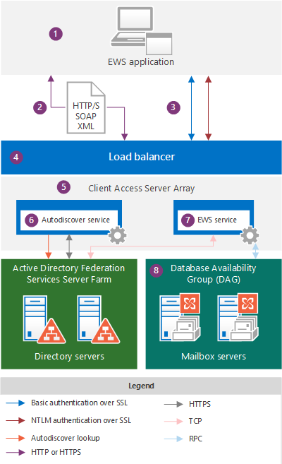

Communication paths as used by EWS applications when communicating with Exchange Online.

Setting up AX for outlook integration

## Email parameter setup

You must setup the email parameters for exchange server before deploying the visual studio projects providing the mentioned functionalities. The following steps assumes you have already imported the following objects in your AX environment:

1. Tables
   1. SysEmailSMTPPassword
   2. SysEmailParameters
   3. SysOutgoingEmailTable
2. BaseEnums
   1. EmailConfirmation
3. Forms
   1. SysOutgoingEmailTable
   2. SysEmailParameters



Once done, you can proceed with the setup:

1. Go to area page node: **System administration -> System -> Email parameters**
2. Fill the exchange server account details

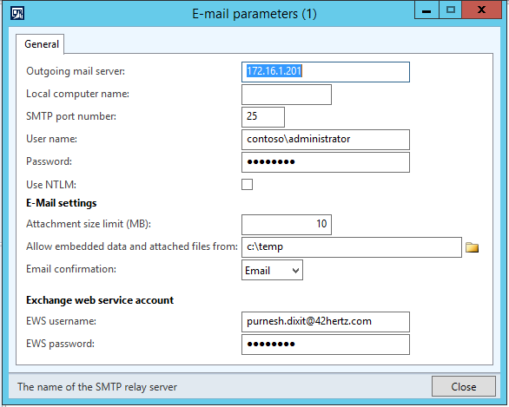

## Deploying Visual Studio Projects

You must deploy these visual studio projects in order to use their methods of class in Dynamics AX. Follow these steps for the same:

1. Import the following objects in your AX environment:
2. EWSIntegrationClassLibrary
3. AsposeIntegrationClassLibrary



1. Edit the imported projects

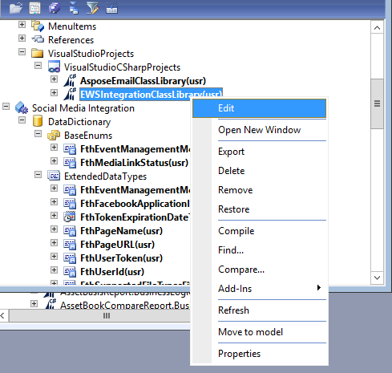

1. Deploy the project

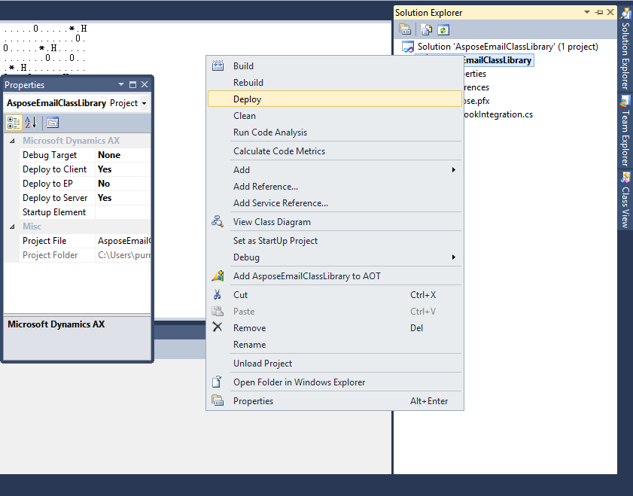

*Note: Make sure your hot swapping is enabled on Microsoft Dynamics AX server*

1. Copy the following dlls to both client and server located in program files of the Microsoft Dynamics AX installed directory
   1. Aspose.Email.dll
   2. Microsoft.Exchange.WebServices.dll
2. Import the following classes in AX environment
   1. FthWorkflow2OutlookDataContract
   2. FthWorkflow2Outlook
3. Run Incremental IL.

Using outlook integration

## Workflow workitem voting emails

To enable the workflow work item to be sent over outlook as voting mail, you have to run the FthWorkflow2Outlook class. You may choose to run as batch as well.

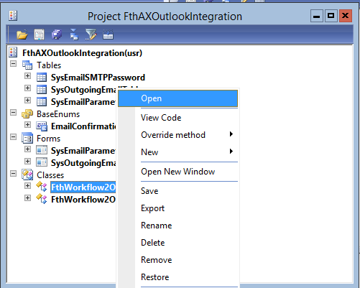

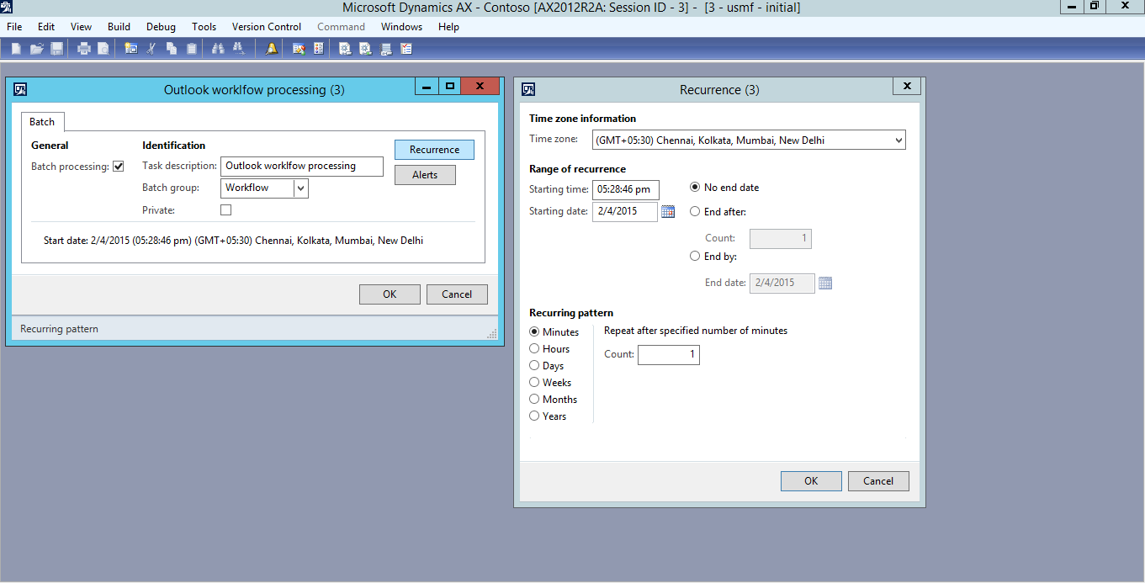

## Outlook Email History

You can see the mails send over outlook on email sending status form under Email processing under in system administration

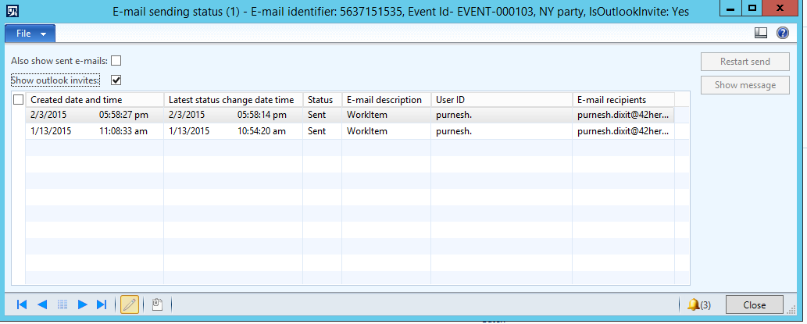

## Calendar invitations

You can use the EWSIntegrationClassLibrary project’s class ‘OutlookIntegration’ and its methods for sending calendar invites using EWS. Follow the following procedure to send calendar invites:

1. Create an instance of **EWSIntegrationClassLibrary.OutlookIntegration**.
2. Call the method **exchangeServiceAuthentication** with parameters – **useremail and password** of exchange server.
3. Bind the outlook instance to some unique ID, if you want to retrieve the invite later on. You can use the method **bindExchangeServiceItem** with unique id as parameter. **This is recommended for requirements of tracking responses.** Unique id must be stored so as to retrieve later**.**
4. Next, you can send the invite using method **sendInvites** with **following parameters - subject, body, recipientList, location, startTime, endTime.**

## Tracking Responses

For workflow work items voting mails FthWorkflow2Outlook class will handle everything. You may choose to customize it according to your requirements. However, in order to track calendar invites responses you can follow the following procedures:

1. You may use the same outlook instance as created in the calendar invitations or you may create a new instance as well as stated before.
2. Call the method **getAttendeeResponse** with the parameter as – **unique id which was used for binding.**
3. Capture the response in a string.